Days 45-46: File System Analysis
// 45-46 OVERVIEW & SCOPE

This block covers file system internals across NTFS, FAT16/32, and EXT4, and applies that understanding through three hands-on exercises: demonstrating NTFS Alternate Data Streams (ADS), running a controlled MACB timestamp experiment, and examining MFT records for test files with MFT Explorer. The comparison document below is written as a standing reference for future investigations, not just for this submission.

// 01 FILE SYSTEM COMPARISON — NTFS

$ Metadata structure
Every file and directory on an NTFS volume has a record in the Master File Table (MFT), including deleted entries until the record is overwritten. Supporting system metadata files include $LogFile (a transaction journal used for crash recovery, which also holds forensic value by recording recent metadata operations), $Bitmap (tracks which clusters are allocated vs. free), and $UsnJrnl (the Update Sequence Number Journal, which logs nearly every change made to files and directories on the volume — this often survives and remains examinable even after the file itself is deleted).
$ Tracking & naming
Each MFT record carries both a $STANDARD_INFORMATION attribute and a $FILE_NAME attribute, each independently storing MACB (Modified, Accessed, Changed, Birth) timestamps. Because these two attribute types are updated by different code paths, a mismatch between them is a well-known indicator of timestomping.
$ Deletion behaviour
Deleting a file flags its MFT record as available and frees the associated clusters in $Bitmap, but neither the record's contents nor the file's data are erased immediately — both remain recoverable until the space is reused. Slack space (the gap between a file's actual data and the end of its last allocated cluster) can retain remnants of whatever data previously occupied that cluster.
$ Forensic artifacts
- Deleted-but-unoverwritten MFT records and file content
- $STANDARD_INFORMATION vs. $FILE_NAME timestamp mismatches (timestomping indicator)
- $LogFile transaction history and $UsnJrnl change history
- Alternate Data Streams (hidden payloads, Zone.Identifier download markers)
- Volume Shadow Copies and slack space remnants
$ Tools
FTK Imager, Autopsy / The Sleuth Kit, Eric Zimmermann's MFTECmd / MFT Explorer, NTFS Log Tracker.

// 02 FILE SYSTEM COMPARISON — FAT16 / FAT32

$ Metadata structure
The File Allocation Table itself is a linked list of cluster numbers describing the chain of clusters that make up each file; two redundant copies are kept on the volume. Directory entries (32 bytes each) store the filename, size, attributes, and timestamps directly — there is no separate metadata file structure comparable to NTFS's MFT.
$ Tracking & naming
Each directory entry stores a starting cluster number and file size, from which the full cluster chain is walked through the FAT. FAT16 is limited to 8.3 filenames; FAT32 supports Long File Names via chained extra directory entries encoded in Unicode alongside the base 8.3 entry.
$ Deletion behaviour
Deletion marks the first byte of the filename in the directory entry with a special value (0xE5) and frees the corresponding clusters in the FAT, but the rest of the directory entry and the file's actual data are left untouched until overwritten — this is why deleted-file recovery on FAT is often straightforward as long as the clusters haven't been reallocated.
$ Forensic artifacts
- Recoverable deleted files (directory entry + FAT chain frequently reconstructable intact)
- Coarser timestamp granularity than NTFS (e.g. 2-second resolution on write time, date-only on access time)
- No built-in journaling — fewer artifacts of past system activity than NTFS or EXT4
$ Tools
FTK Imager, Autopsy, TestDisk / PhotoRec.

// 03 FILE SYSTEM COMPARISON — EXT4

$ Metadata structure
Every file and directory has an inode, storing permissions, size, timestamps, and pointers to its data (via extents in EXT4, replacing the indirect block pointers used in EXT2/3). A journal (jbd2) logs metadata — and optionally data — changes before they are committed, primarily for crash consistency.
$ Tracking & naming
Inodes have no filename of their own; directory entries map a name to an inode number, and multiple directory entries (hard links) can point to the same inode.
$ Deletion behaviour
Deleting a file removes its directory entry and decrements the inode's link count; once that count reaches zero, the inode is marked free. Notably, EXT4 (unlike EXT2/3) typically zeroes out the extent/block-pointer information within the inode on deletion, which makes deleted-file recovery on EXT4 substantially harder than on EXT2/3, FAT, or NTFS — a distinction worth highlighting when comparing recoverability across file systems.
$ Forensic artifacts
- Journal (jbd2) remnants of recently modified metadata/data, sometimes surviving after deletion
- Orphan inode list (inodes pending deallocation)
- Deleted-but-still-open file handles reachable via /proc/<pid>/fd on a live system
$ Tools
The Sleuth Kit (istat, icat), extundelete, ext4magic, Autopsy.

// 04 NTFS ALTERNATE DATA STREAMS (ADS)

A hidden stream was created and attached to a test file using notepad file.txt:hidden.txt, then confirmed invisible under normal access and visible only when explicitly queried (dir /r or PowerShell's Get-Item -Stream *). A legitimate Windows-created stream (Zone.Identifier, attached to internet-downloaded files) was checked as a contrast case for benign vs. suspicious ADS use.
$ Findings
- The hidden stream added zero bytes to the file's visible size and did not appear in a normal dir listing or when opening the file normally
- dir /r (or PowerShell's Stream parameter) revealed the stream name and size explicitly
- Accessing the stream by its full name (file.txt:hidden.txt) returned the hidden content in full
- Downloaded files carried a legitimate Zone.Identifier:$DATA stream, confirming ADS is also used for benign OS-level tracking, not only for hiding data
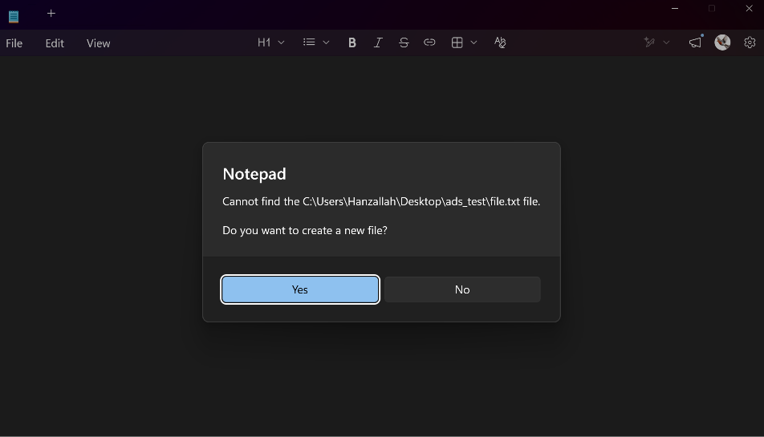

Fig. 1 — File appearing normal without /r (baseline)
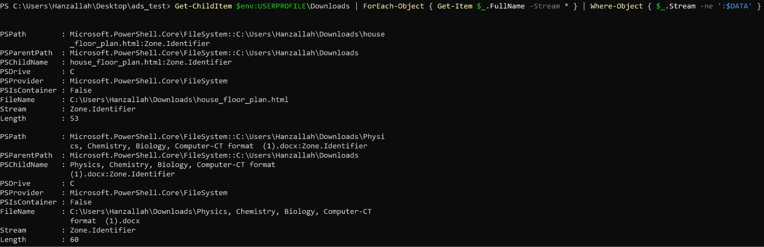
Fig. 2 — Stream revealed via dir /r or Get-Item -Stream *
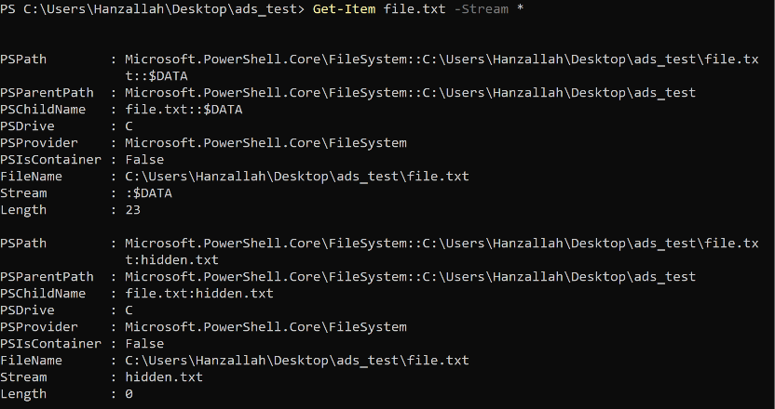

Fig. 3 — Hidden stream content accessed directly (file.txt:hidden.txt)
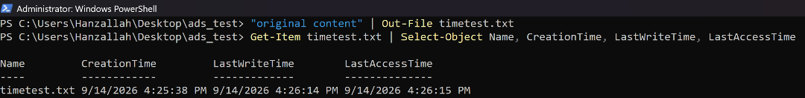
Fig. 4 — Legitimate Zone.Identifier stream on a downloaded file (contrast case)

// 05 MFT ANALYSIS

Eric Zimmermann's MFT Explorer (EZ Tools suite) was installed and used to load an extracted $MFT file and examine full records — including $STANDARD_INFORMATION and $FILE_NAME MACB timestamps and file attributes — for individual test files.
$ Setup
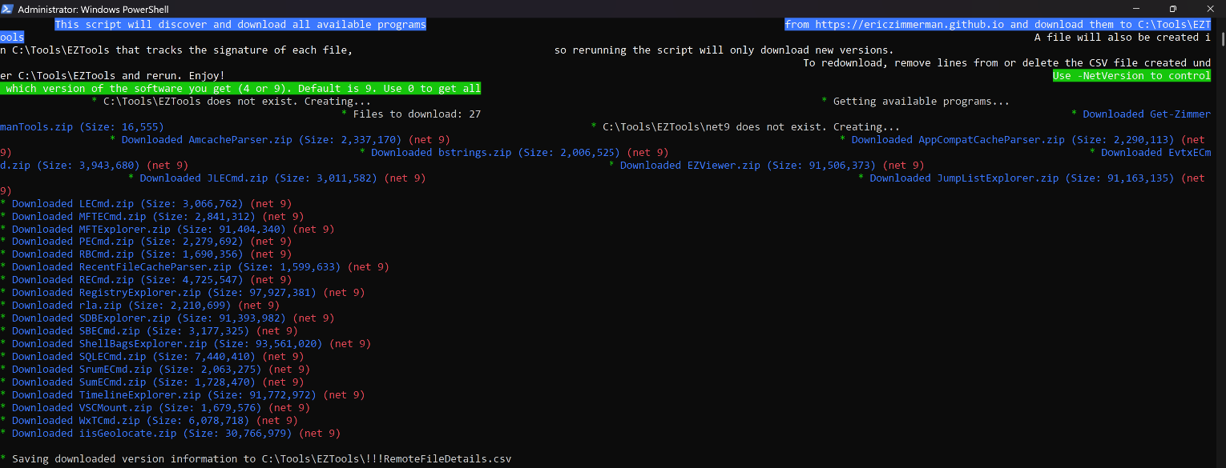
Note: $MFT only exists on NTFS volumes. Test files created on exFAT (Ventoy) or FAT (VTOYEFI) volumes from the Days 43-44 image have no MFT records; test files for this section were created on an NTFS-formatted volume instead.

$ Records examined
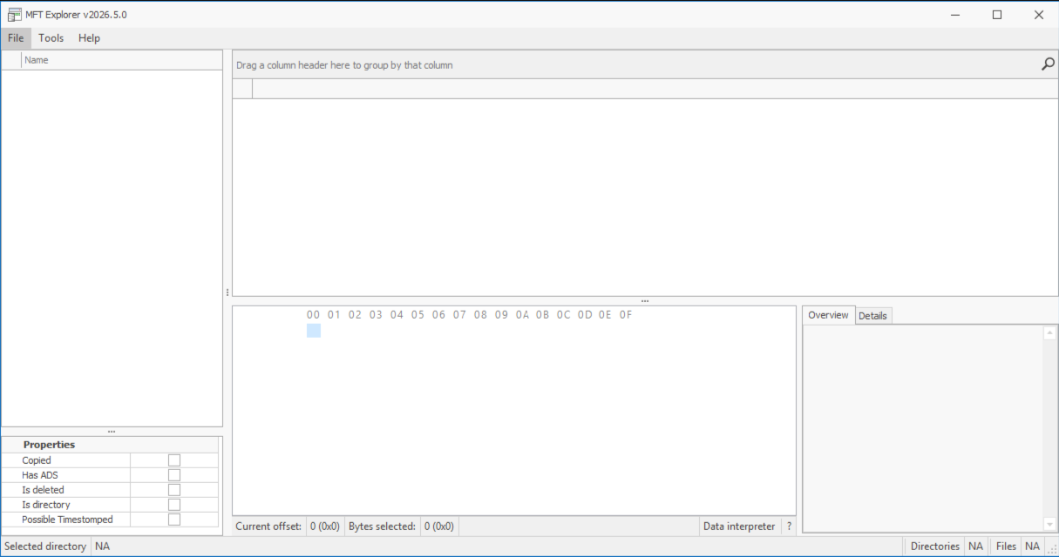
Fig. 5 — MFT Explorer: full record for test file 1, showing MACB timestamps and attributes

// 06 DELIVERABLES CHECKLIST

- File system comparison document — Sections 01–03 (complete)
- ADS demonstration screenshots — Section 04 ( procedure verified)
- MFT analysis screenshots — Section 06 (pending — requires NTFS test files + $MFT extraction)
- Windows artifacts reference sheet — Section 05 (actual timestamp values)

